**Paper Roll Convey Machine Design**

Design Proposal

Mechanical Design II: 2254 MEMS 1029 SEC 1040

Apr 1, 2025

*- Prepared by -*

Irving Zhang, Anna Liu, Zhemeng Chen

# **Problem Summary and Assumptions**

1. **Key Problem Requirements**

This project focuses on designing an industrial roll transfer machine that employs motors and gears to rotate a V-shaped cradle by 90 degrees, facilitating the transfer of paper rolls from the production line to a forklift. Each complete cycle is designed to take 90 seconds, allocating 45 seconds for the transfer operation and 45 seconds for the cradle to return to its initial position, ready for the next cycle. The design prioritizes minimizing both cost and power consumption while maximizing efficiency. Furthermore, the selected materials and components are engineered for durability, ensuring a lifespan exceeding 10 years under continuous operation—16 hours per day, 5 days a week—with an expected throughput of 30 paper rolls per hour.

Each team member is responsible for one part of the components used in the machine, including Lead, screw, gears, and bearings. The division of labor is broken down as shown in the table below

| Team member | Part |
| --- | --- |
| Irving Zhang | Lead Screw |
| Anna Liu | Gears |
| Zeemo Chen | Bearings |

Table 1. Team member responsibilities for components

1. **Assumptions**

* The entire machine:
  + The operating temperature and environment are moderate
  + Components are kept at a stable, efficient, and suitable operating temperature
  + System of measurement: Metric
* Cradle & roll
  + The roll is always close to the arm of the cradle during rotation, so there will be no additional shock load. The density of the paper is
  + Both cradle and shaft are made of steel, whose density is
  + Each arm is considered solid.
* Power screw:
  + Acme thread—When the lead screw is taking axial force, the lead angle λ is small enough to be neglected, only the effect of thread angle α considered.
  + Trapezoidal thread shape with a thread angle α=14.5 deg
* Gears
  + All gears are spur gears.
  + The pressure angle is 20 degrees.
* Bearing:
  + The bearings remain smooth enough for the duration of the work.

# **Preliminary Design**

[ME2-Proj2-G3-CADfiles](https://drive.google.com/drive/folders/11D0ARZcbQfixSLjWwraqTq8gMx8DQbzv)

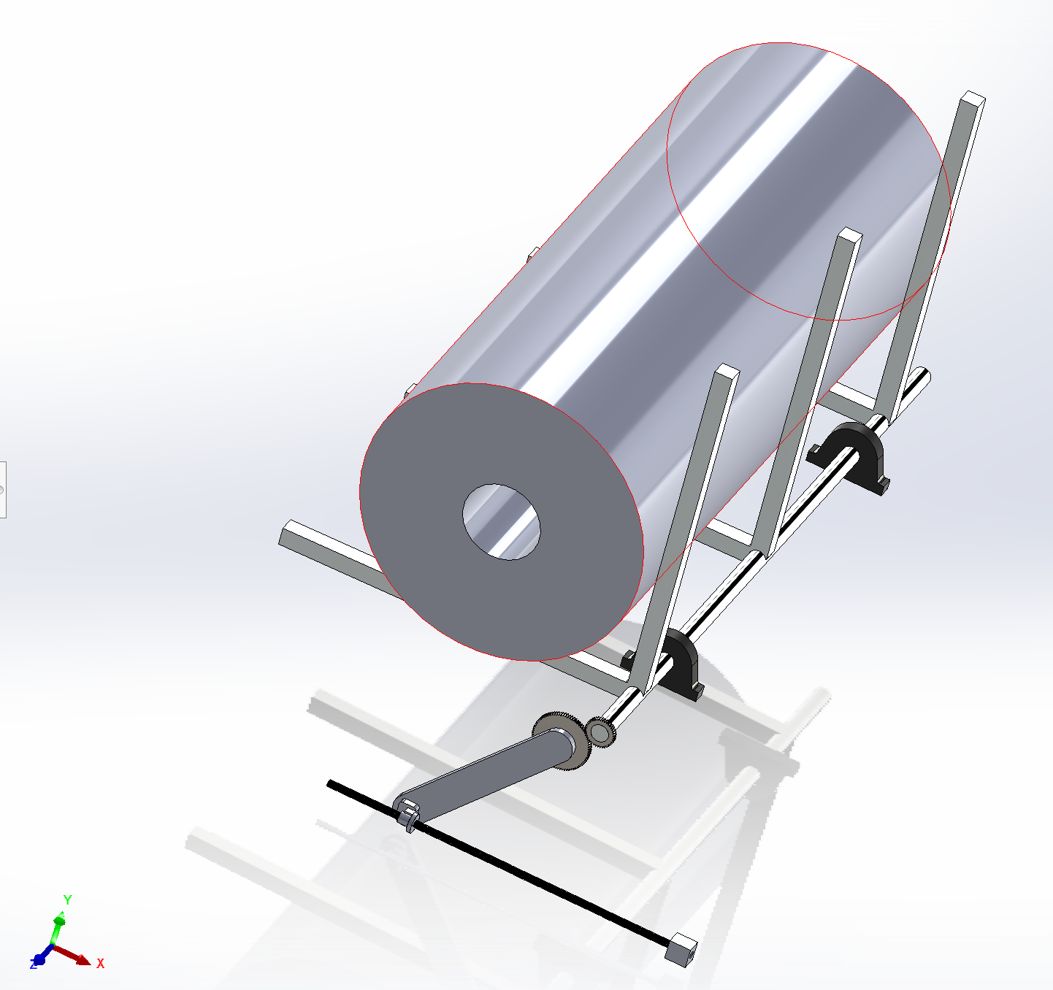

Figure 1. Preliminary Design of the machine

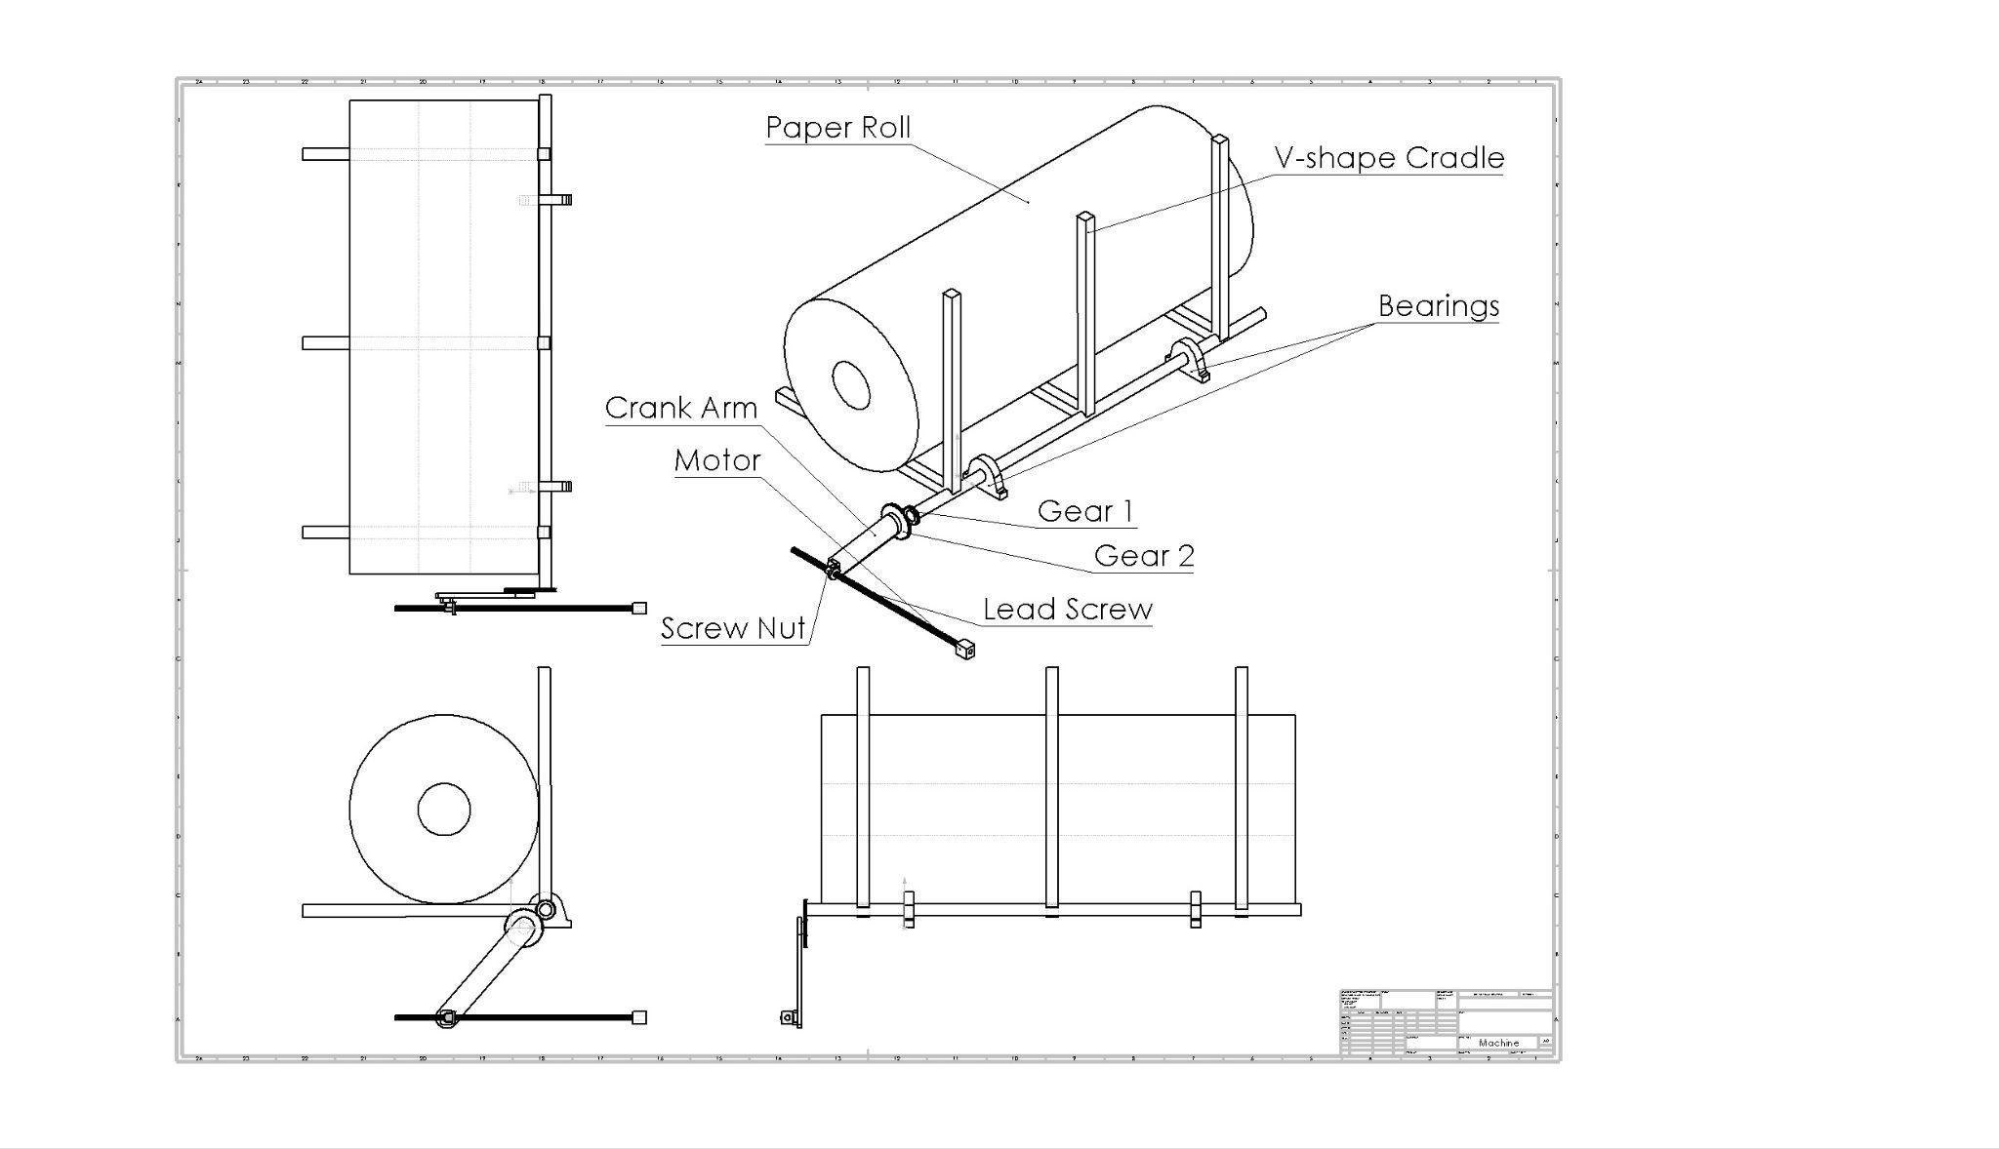

Figure 2. Drawing of the machine in standard three view and isometric view

1. **Power Screw:**

* Self-locking: When a positive torque is obtained, the screw is said to be self-locking. Thus the condition for self-locking is

or

Where,

[mm]

[deg]

* Collar friction:

Where *N* is the normal force on the thread.

* Thread failure:

We use the von Mises theory to analyze thread failure:

1. Stress element:

1. Three-dimensional von Mises stress:
2. Compare against the yield strength of the material

Where *n* is the factor of safety > 2.0.

The nominal shear stress τ in torsion is

The axial nominal normal stress σ is

Where,

, *d* is the major diameter

The bearing stress is

Where *nt* is the number of engaged threads.

The thread-root bending stress *σb* is

The tangential shear stress *τzx* is

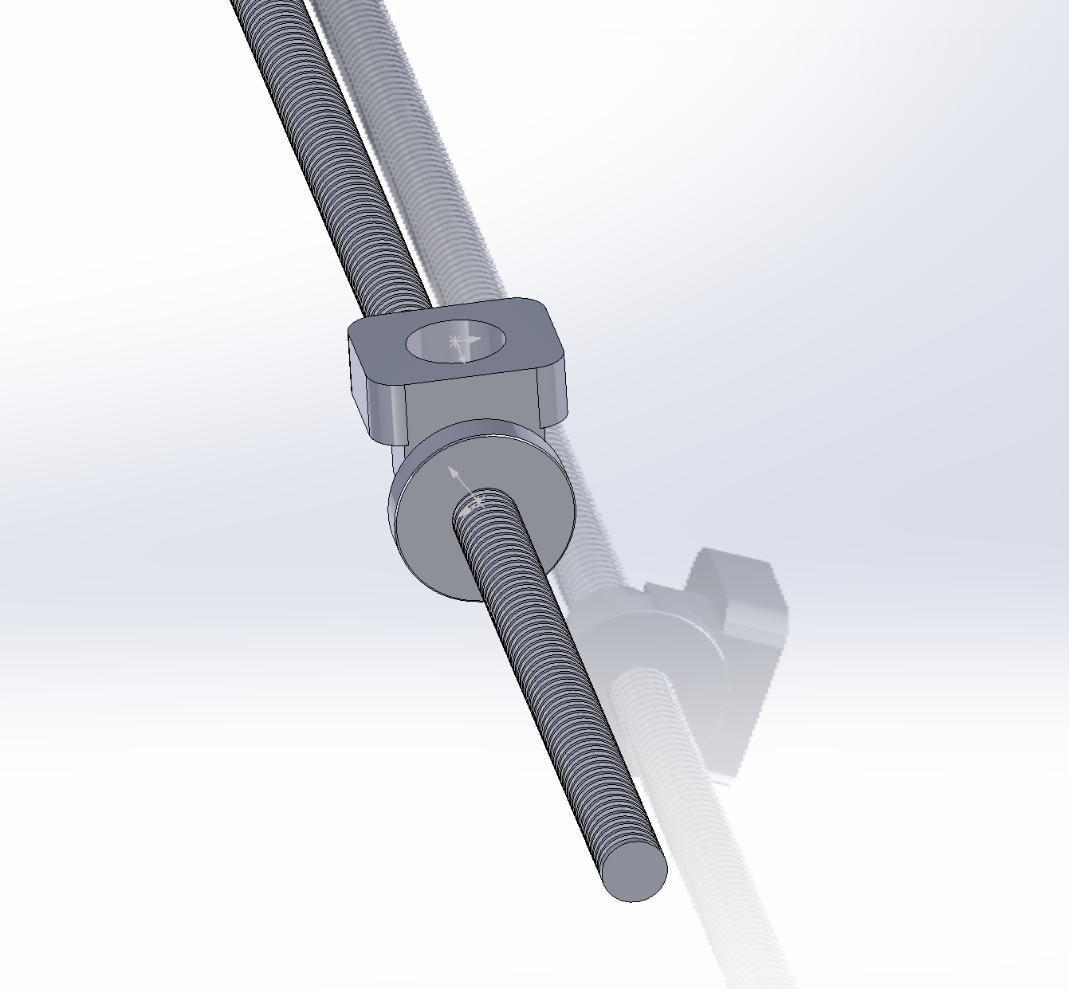

Figure 3. Preliminary lead screw and nut design

1. **Gears**

Gear 1 and Gear 2 are both spur Gears. These two gears should be able to undergo sufficient stresses.

* Location:

The gears are strategically positioned at the end of the cradle shaft to directly control the rotation of the V-shaped cradle.

**Gear 1**: This gear is attached to the cradle shaft. It meshes with Gear 2, converting the rotational motion into the precise movement needed to rotate the cradle through 90 degrees.

**Gear 2**: This gear meshes with Gear 1 and connects with a crank arm. This gear receives the rotational torque from the crank arm.

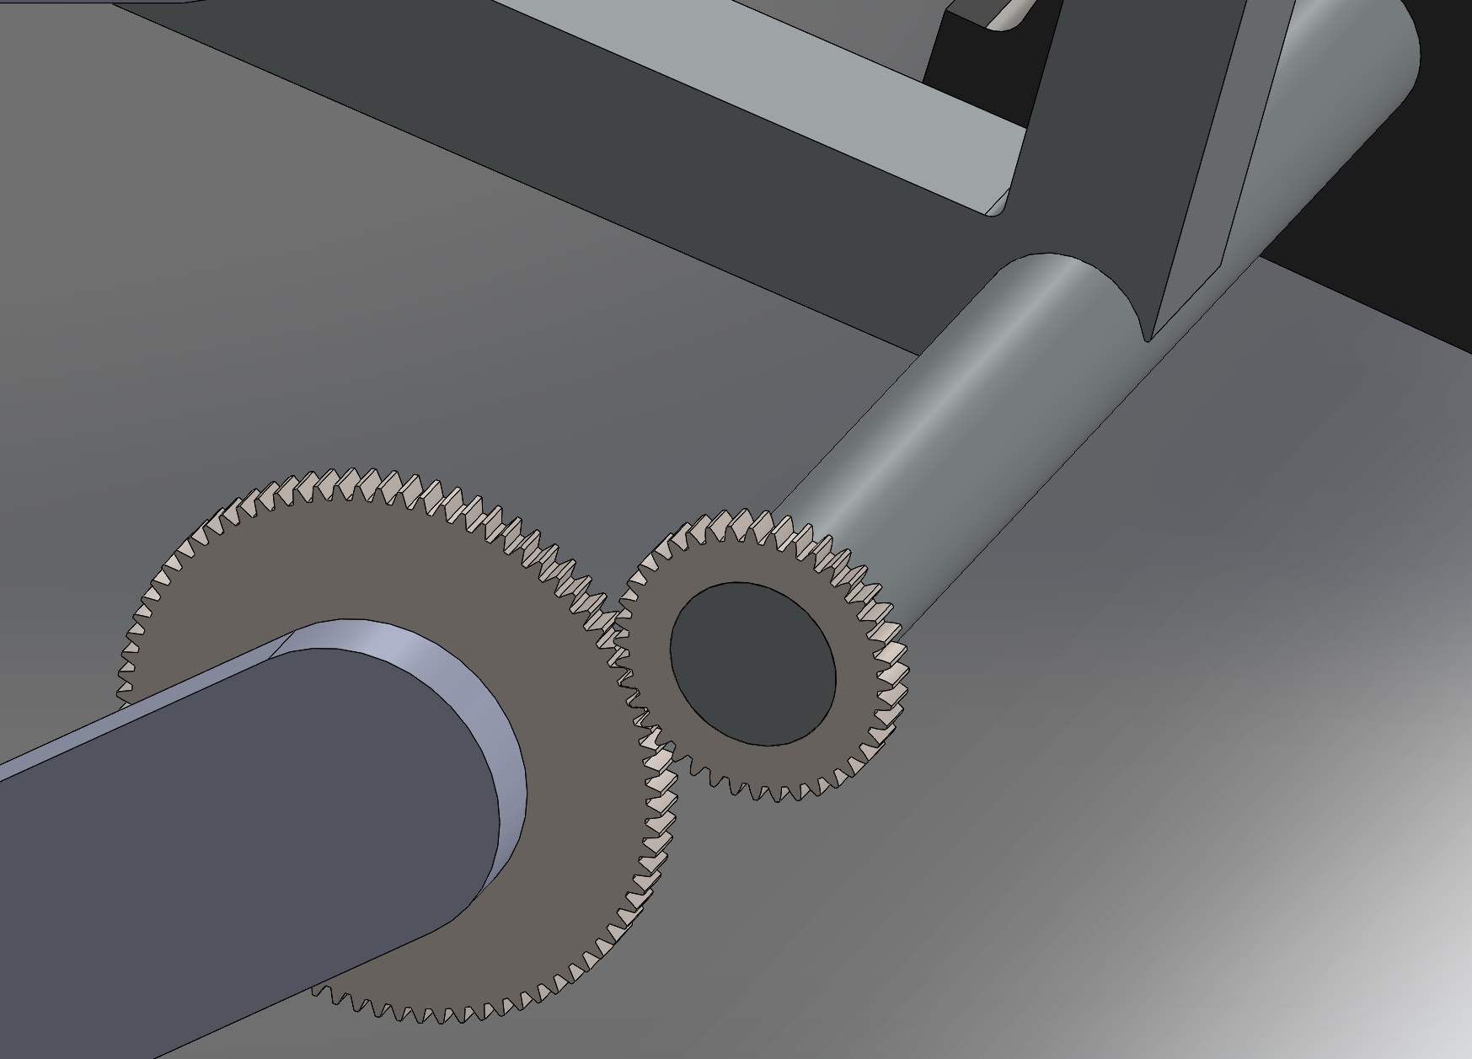

Figure 4. Location of the two gears

* Teeth Failure:

We use the Lewis Equation to estimate the stress in gear teeth.

Where,

[N]

[mm]

[mm]

Due to the safety implications of this machine, all components should have a factor of safety > 2.0, so

So for our gears, the yield stress of the gears must satisfy:

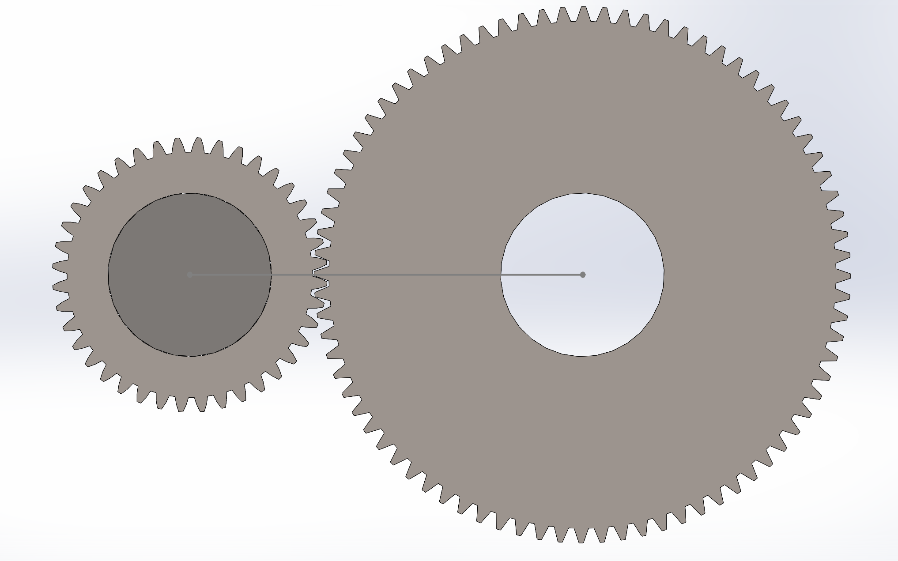

Figure 5. Front view of the sketch of the gear train

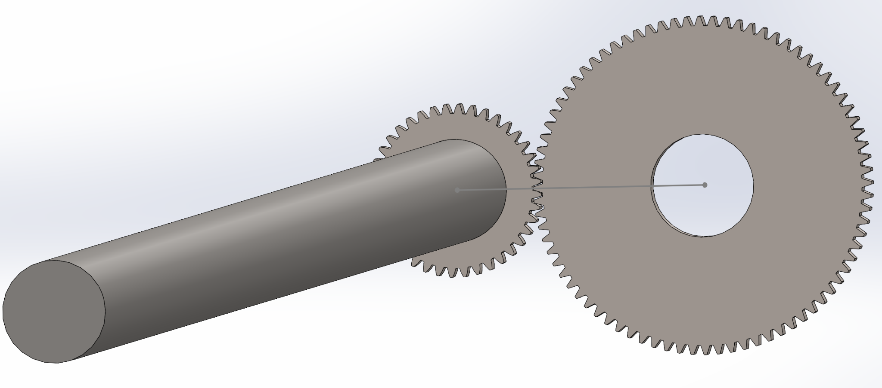

Figure 6. Preliminary gear train design with shaft

1. **Bearings:**

* Type: Roller bearings for high load capacity

The bearings should be able to support the total weight of the roll, cradle, and shaft.

Where,

The roll has an outer diameter of 0.8m, an inner diameter of 0.22m, and a length of 2m. The density of the paper is . So the weight of the roll is 3642.79kg.

To better carry the industrial roll, we set the length of the shaft to 2.1m, slightly longer than the roll, and the diameter to 50mm. The density of the steel is approximately , so the weight of the shaft is 32.368kg.

The cradle is a V-shaped structure and consists of 6 square steel box beams, each beam, also called an arm, has 2 inches (50.80mm) in sides, 1 meter in length, and 2025.80kg per arm. So the total 6 arms weigh 12154.81kg. Since we are not sure what the inside size of the box beam is, we consider the entire beam to be solid to provide the maximum load to the bearing and reduce the possibility of overloading in reality.

Combine all the weight bearings that need to be supported; from the force analysis, each bearing should be able to support at least 77645.94N.

* Mounted Style: Pillow block with high load capacity. The preliminary CAD modeling sketches are shown below. The outside black component is the pillow block while roller bending is embedded in it.

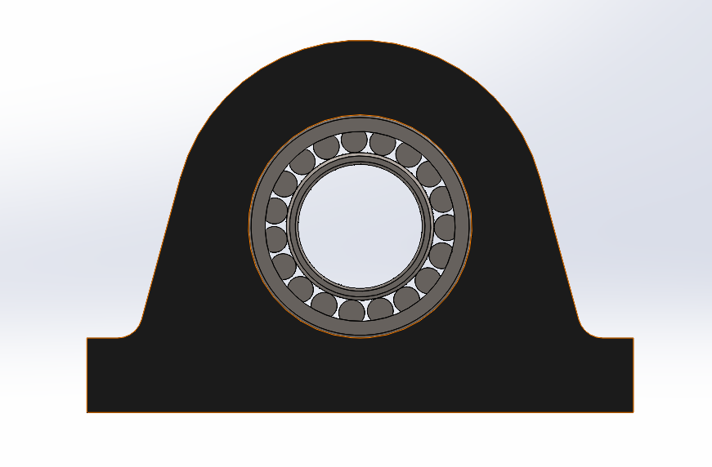

Figure 7. Front view of the preliminary mounted bearings design

* Locations: As shown in the schematic below, each bearing is positioned 150mm outward from the inner faces of the side arms. This spacing was intentionally chosen to avoid placing the bearings too close to the center of the shaft. This location can reduce the bending moment on the shaft caused by the concentrated load of the paper of the roll and cradle, thereby minimizing the deflection during rotation as much as possible and avoiding excessive stress concentrations at the middle of the shaft. This configuration also helps prevent premature fatigue failure.

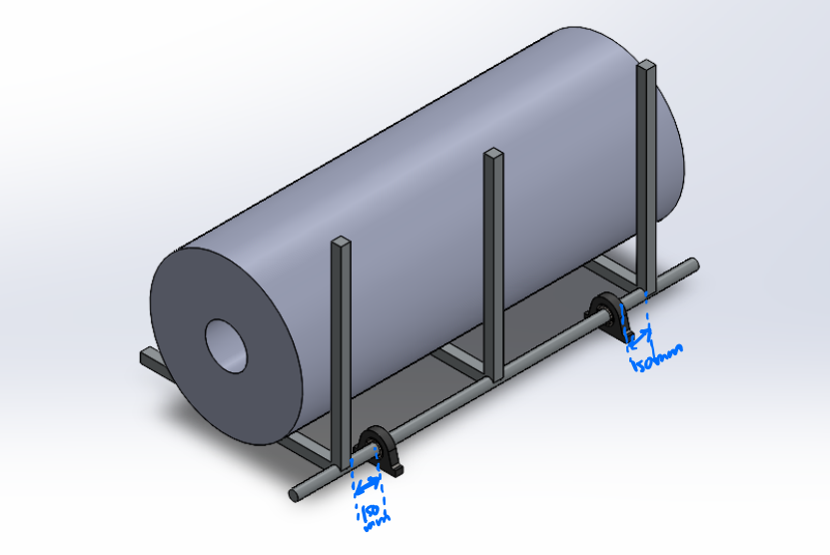

Figure 8. The schematic shows the position of the bearings

* Lifetimes: According to the equation , and the given minimum working hours requirement, we can get the minimum dynamic load rating C. The final selected bearings should meet the specifications.

# **Free Body Diagrams**

Figure 9. Free body diagram of cradle and paper roll

1. Gears

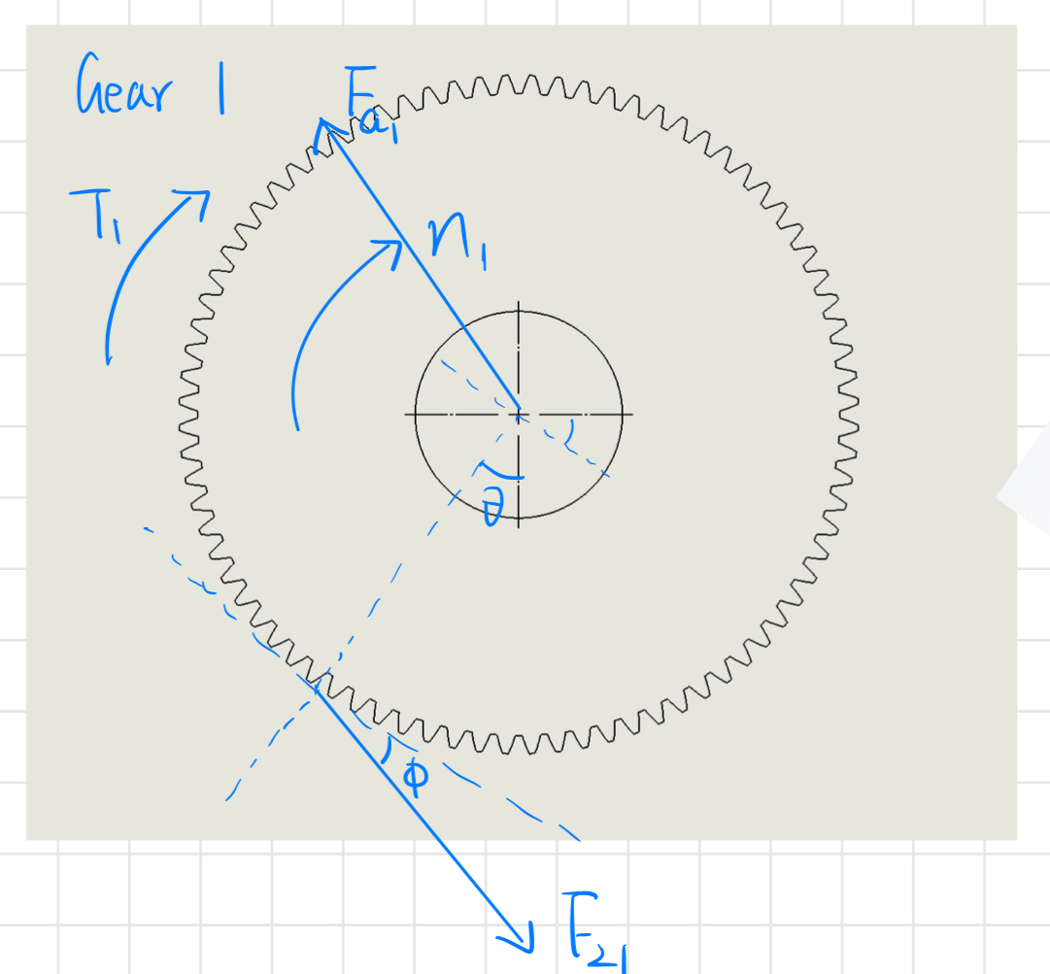

Figure 10. Free body diagram of Gear 1

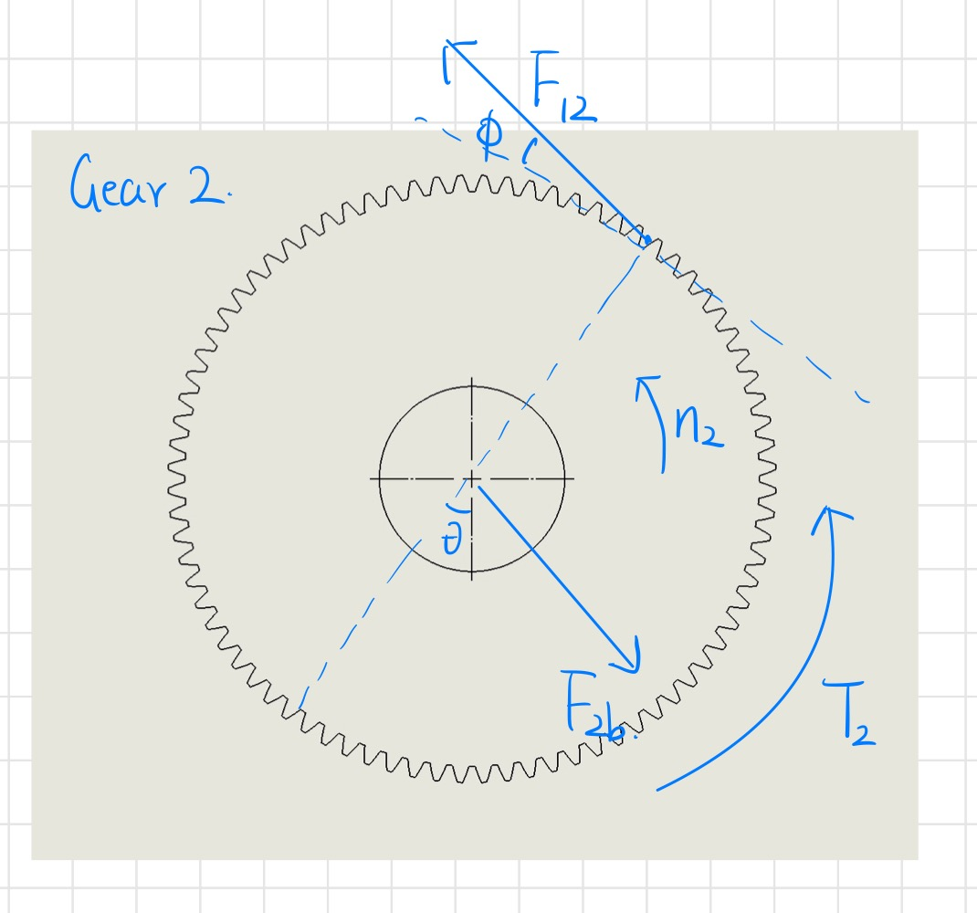

Figure 11. Free body diagram of Gear 2

1. Bearings

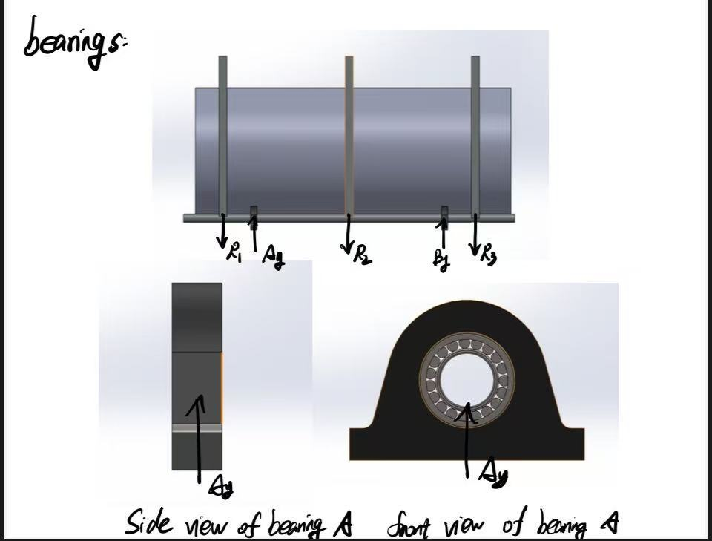

Figure 12. Free body diagram of bearings

1. Power screw

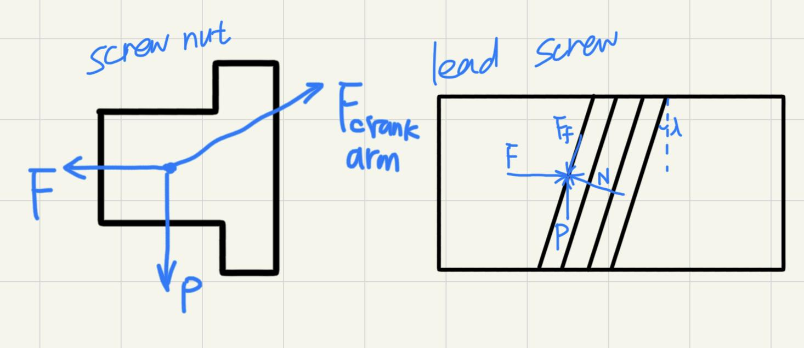

Figure 13. Free body diagram of the lead screw

# **Preliminary Calculations**

The mass of the paper roll is

The force required to lift or convey the roll is equal to the weight of the roll and the cradle:

We must provide enough torque to move the roll, so the torque we need is:

The torque for the roll is equal to the torque from the gear 1.

Where is the pressure angle.

For the bottom gear 2, the torque is :

Where and are the teeth number of two gears.

The total power to move the crank is:

The angular velocity is constant:

, where [sec]

For power screw,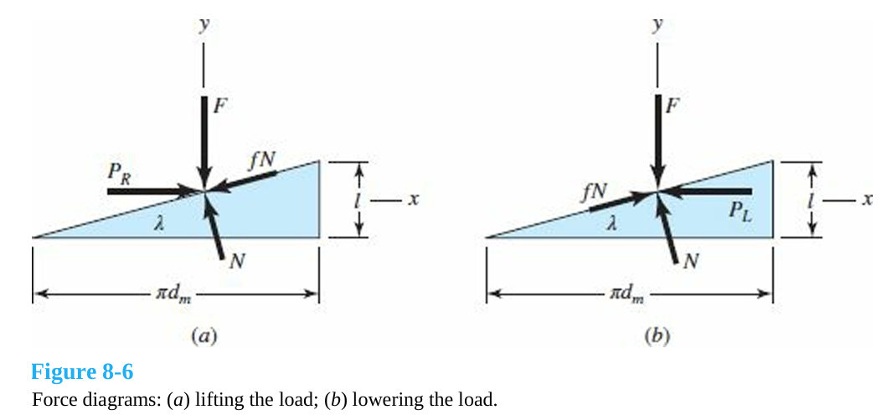

Figure. 14 Force diagrams of screw threads (a) lifting the load; (b) lowering the load.

We use equilibrium equations in x and y directions, solving for *PR* and *PL*:

Then, find the torque required by multiplying the load *P* with the mean radius *dm/2*,

To find on the power screw, we need find the force on the crank arm .

From the FBD on the gear 2, we could know that:

From the FBD on the screw nut, we could know:

# **Bill of Materials**

Key items: gears, bearings, pillow blocks, power screws(no need to finish-identify the components

| Part | Product Name | Material | Quantity | Yield Strength[MPa] |
| --- | --- | --- | --- | --- |
| Gear 1 | Spur Gear 2M 40T 20PA 12FW | AISI 1020 | 1 | 351.571 |
| Gear 2 | Spur Gear 2M 80T 20PA 12FW | AISI 1020 | 1 | 351.571 |
| Lead Screw | Lead Screw Trapezoidal Thread M20x4mm | AISI 1018 Carbon Steel | 1 | 370 |
| Screw Nut | Flange Nut Trapezoidal Thread  M20x4mm | 932 Bearing Bronze | 1 | 125 |
| Bearings | Spherical-roller bearing | Steel | 2 | / |
| Pillow Block | SNL 510-608 plummer/pillow block | Cast iron | 2 | / |

Table 2. Bill of materials

# **Future Work**

1. Conduct detailed load analysis for all mechanical components, ensuring compliance with safety factors.
2. Finalize the selection of commercial components, including gears, bearings and lead screws, with vendor specifications and cost analysis to minimize the power and cost while maximize the efficiency
3. Analyze potential failure points for durability and reliability over the expected 10-year lifespan.
4. Optimize gear ratio and lead screw parameters to achieve smooth motion and minimize power consumption. Ensure self-locking capability of the lead screw.